**University of Petroleum and Energy Studies**

School of Computer Science

Department of Cybernetics



**Graphics & Animation Tools**

**Project Report**

**(Session: 2020-2021)**

Course: B. Tech with Specialization in Open Source and Open Standards

Batch: 2017-2021

Semester: VIIth

**Submitted By:**

Aditya Malik

R100217003

500061968

**Submitted To:**

Dr.Durgansh Sharma Assistant Professor

Department of Cybernetics

**Aim:**Design of 3D gun model.

**Steps followed:**

1. Open Blender.
2. Clear the default interface of the blender by deleting or hiding the cube.
3. After emptying the screen, go to view and click background image, load, then choose a picture of the weapon you want
4. Go to top view and add a square, then delete two of the vertices and place one of the remaining on a point on the picture, and the other out of the way.
5. Select both vertices and subdivide.
6. Move the generated point to the next good-looking spot on the picture
7. With that selected still, select the outside vertex also, and subdivide.
8. Continue until you are on your third to last one, then select your outside vertex and move it where you would move the next vertex.
9. Select the first and last vertices and go to mesh>>make edge/face
10. Extrude to half your preferred thickness, then extrude the rest of the way.
11. Select the center vertices on the blade, and scale up.
12. Then move vertices to your liking.
13. Select the vertices of the handle, go to mesh>>vertices>>separate.
14. Add a modifier, choose subSurf, turn up the level until it looks close to what you want without too many vertices. Click apply next to the modifier.
15. Modify vertices (using proportional edit helps) to your liking.
16. Go to object mode, and turn off double-sided on any meshes that are.
17. If black appears on any parts of the mesh, highlight it, go to edit mode, select all vertices, go to mesh>>normals>>recalculate outside.
18. If there is still black, select those faces and go to mesh>>normals>>flip.
19. If there is still black, then you are missing a piece of mesh. Highlight the vertices around the hole, go to mesh>>vertices>>fill.
20. If black did not appear, then select everything (in object mode) and go to object>>join objects and say yes.

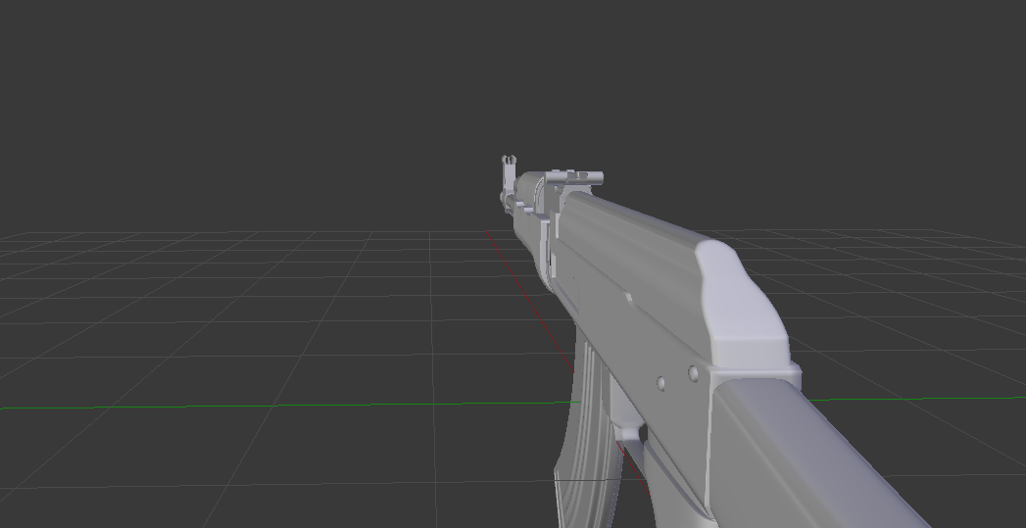

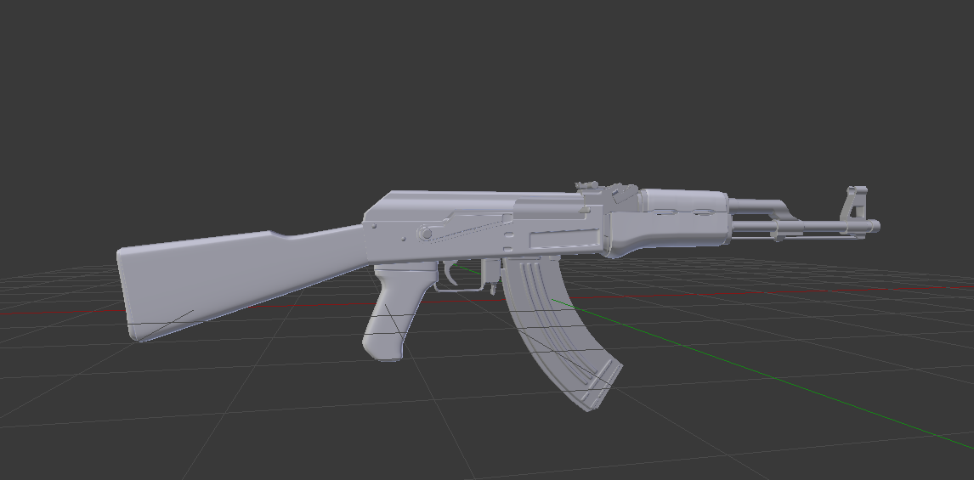

**Drive Link : https://drive.google.com/drive/folders/17KDc5WUVq75kEXZ4sPhWa3p-Pjz16-5u?usp=sharing**